

Critical Design Review
Data Package Document 3
James Allworth | 312073038 | Attitude Determination & Control
Thomas Forbutt | 312101058 | Communications and Data Handling
Oscar McNulty | 312106130 | Structural Design & Development
Penelope Player | 312106718 | On-Board Computer and Power System
Nikita Sardesai | 312088205 | Thermal Systems and Payload

Group E: SnapSat
Assembly Integration and Test Plan

Contents
1 Scope 2
2 Materials 2
2.1. SnapSat Components 2
2.2. Assembly Tools Required 3
3 Satellite Layout 3
3.1. Internal Structure 3
3.2. External Structure 3
4 Satellite Assembly 5
4.1. Internal Assembly 5
4.2. External Assembly 5

Scope
This document will detail the proposed process on assembling SnapSat. It is the first iteration of assembly so there is no doubt that there will be future changes in the procedures. The document will be expanded as required; changes along with the date on which they were made are included in table 1.1 below.
Table 1.1 - Integration changes made
Date | Section | Details of changes made

Materials
Outlined in the table below are all the components and tools which will be required to build SnapSat, they are broken down into the subsystems.

SnapSat Components
Table 2.1 – List of components selected
Subsystem | Components
Thermal | Kapton tape  Temperature sensors
Attitude Determination and Control | Inertial Measurement Unit (IMU, Adafruit 10DOF)  OSRAM Photodiodes  Magnetorquer (to be assembled)
On-Board Computer | Iduino DUE (with USB serial connector)  Printed circuit boards
Power System | Batteries (x4)  USB DC Charger (x4)  DC Regulators (x2)  Current sensors (x4)  Solar Panels (x9 for fold out design, x3 for testing)
Communication and Data Handling | Comms Tx and Rx  Rubber duck antennae  GPS (Pico Breakout with Chip Antennae)
Structure and Integration | 3D Printed ABS plastic (6 panels)
Payload | Arducam Mini  SD Card

Assembly Tools Required
Table 2.2 - List of tools required for assembly
Subsystem | Tools Required
Thermal | n/a
Attitude Determination and Control | Copper wire (length)  Winding machine  Epoxy (superglue)
On-Board Computer | Components here
Power System | Components here
Communication and Data Handling | Components here
Structure and Integration | Screws, screwdriver and epoxy

Satellite Layout
This section will give and overview on the general layout of all the internal and external components of the satellite. Also included are Solidworks parts drawings and detailed assembly drawings – along with a full 3D CAD model.
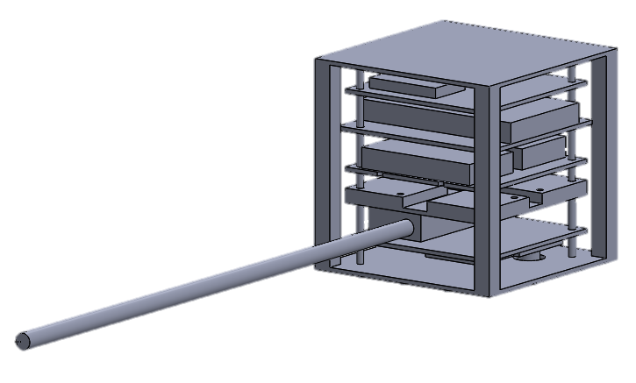
Figure 1 – Schematic of internal structure

Internal Structure
<describe the internal structure and layout – assembly instruction are in the following section so be general here>

External Structure
After the internal structure has been completed, the chassis will be covered in kapton tape for thermal insulation and then the solar panels installed. The solar panels will be attached to the structure with screws.
Please describe the satellite layout both internally and externally and also include CAD models (or hardware) to help with the visualization. An example is provided below.
Layout of Main Tray and –Z Panel
The main tray layout houses the radios as well as the secondary payload as shown in Figure 1a. The secondary payload is attached to the main tray via 5 screws. The S-band enclosure is housed within the main tray itself. The UHF enclosure not only contains the UHF Rx but also serves as a shield for the S-band Tx. UHF enclosure is attached to the S-band enclosure using four screws: two screws were positioned next to the S-band SMA connectors while the other two were positioned at the back end of the UHF enclosure, also serving to secure the UHF cover. This second pair of screws passes through the UHF cover and enclosure and screws into the main tray behind the S-band.
The internal layout of the -Z panel is organized in different layers as shown in Figure 1b. Attached closest to the panel itself are the separation switches, magnetometer, and the Z magnetorquer. The second layer is the power system, which is mounted to the panel through nine size zero screws. The HKC was to be mounted above the power system.

Figure1a: Main tray layout Figure 1b: -Z panel layout

Layout of Other Internal Components
The only other internal components are the X and Y magnetorquers which are mounted to the -X and -Y panels, respectively.

Layout of External Components
The external layout of the satellite consists of solar cell coupons, deployable UHF antennas, test port and S-band patch antennas which may be seen in Figure 2. Two of the long faces have two solar coupons each while the remaining four faces each have only one coupon. Both the main tray and the -Z panel have two deployable UHF antennas. In addition to the UHF antenna, the -Z panel also has the test port. The S-band patch antennas are on the -X panels towards the -Y side of the satellite.
Figure 2: External layout

Satellite Assembly
Before any assembly, at least three structural panel must be put together to form a corner section of the cubesat. After this, the components may be put in.

Internal Assembly
The internal assembly procedure is as follows
- Screw PCBs onto M4 bolts travelling through the superstructure
- Attach the M4 bolts to the top half of the cubesat structure
- Plug in solar panels, temperature sensor, sun sensors etc…
- Attach the other cubesat structure plates

External Assembly
The external assembly procedure is as follows
- Steps
- After the chassis is complete, the structure will be wrapped in a layer of kapton tape. The tape will be continuously dispensed form the roll and applied to the body. Gaps will be present for the antennae and camera
- The solar panels will then be screwed on to the sides
Please include a description of the assembly procedure of the CubeSat at a spacecraft level. It should also be accompanied by a CAD model indicating how the integration will take place. An example is provided below.
- Assemble main tray:
- Fasten battery
- Fasten S-band radio
- Assembly UHF radio
- Mount UHF enclosure/S-band radio cover
- Fasten UHF radio cover.
- Fasten the -Y solar panel to main tray
- Assemble -Z panel:
- Mount separation switches, magnetometer, and Z magnetorquer;
- Fasten power system
- Mount HKC and HKC attachment plate
- Fasten -Z panel to -Y solar panel
- Integrate -X solar panel (might need temporary supports to hold the -Z panel and the main tray in place)
- Remove -Y panel:
- Connect S-band coaxial cables to patch antenna on the -X panel.
- Integrate +X solar panel:
- Connect S-band coaxial cables to patch antenna on the +X panel
- Fasten -Y panel to -Z panel and main tray.
- Integrate secondary payload
- Integrate drag sail modules
- . Integrate +Y panel

Figure 3: Spacecraft-level assembly procedure

Sometime after assembling all panel structures (but before putting in the solar panels) we need to wrap the structure in kapton tape.

